**Pushing Images in nexus repository manager 3 :**

Sharing an image can be achieved by publishing it to a hosted repository. This is completely private and requires you to tag and push the image. When tagging an image, you can use the image identifier (imageId). It is listed when showing the list of all images with docker images. Syntax and an example (using imageId) for creating a tag are:

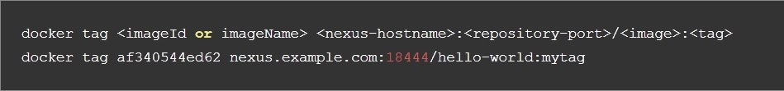

For us (Baharan nexus ):

docker tag af340544ed62 192.168.253.10:8083/Amad:latest

Once the tag, which can be equivalent to a version, is created successfully, you can confirm its creation with docker images and issue the push with the syntax:



For us (Baharan nexus ):

docker push 192.168.253.10:8083/Amad:latest



A sample output could look like this:

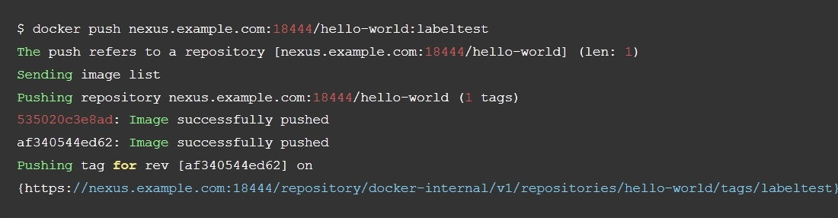

Now, this updated image is available in the repository manager and can be pulled by anyone with access to the repository, or the repository group, containing the image. Pulling the image from the repository group exposed at port 18443 can be done with:



docker pull 192.168.253.10:8083/Amad:latest

Prior to push, and depending on your configuration, repository manager login credentials may be required before a push or pull can occur.

Pushing large images can result in failures due to network interruptions and other issues. These partial uploads result in temporary storage for these transfers in the repository manager filling up. The task Purge incomplete docker uploads can be configured to delete these files. If you also tend to upload images to the same tag repeatedly, this can leave a lot of dangling images around, consuming a lot of space. The task Purge unused docker manifests and images can be configured to remove these files.

By : MM.Hafezieh